6.2.2 The functioning of the institutional bodies is effective and efficient as visible from policies, administrative setup, appointment and service rules, procedures, etc.
The institute has a vision to be a centre of excellence in Education and Technology committed towards socioeconomic advancement of the country. The leadership of SIESGST is through participative management all the way through structured organizational system with the involvement of all the Stakeholders.
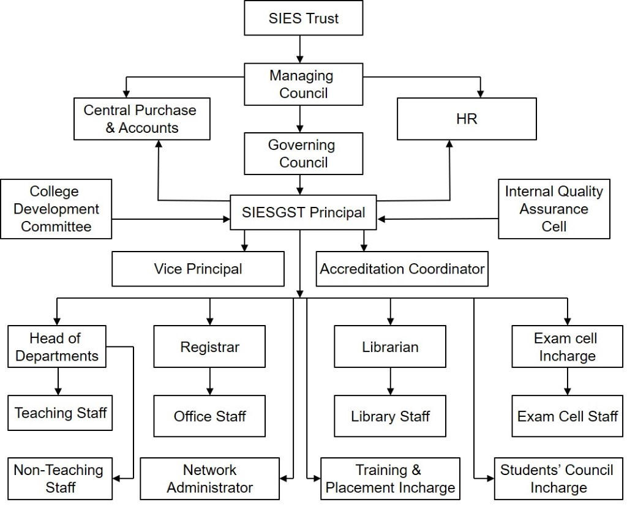
The key components of organizational structure of the college are Governing Body (SIES President and managing council), SIESGST Principal, Head of the Departments, Teaching staff, Non-teaching staff and Support cells/Departments. It reviews the institutional strategic plan which in turn sets the academic aims and objectives of the institution and identifies the financial and recruitment strategies. The organizational structure lends itself to sustaining institutional capacity and educational effectiveness through the involvement of external members in various Committees/ Boards. Various stakeholders of the institute are members of different committees constituted by the institution. The decision-making procedures are made at appropriate levels in the organizational hierarchy.
As per the university/ government guidelines, IQAC Cell, Anti-ragging Cell etc. are also in place for the institution. There are various committees with well-defined functions that give academic and administrative leadership to the institution. A committee comprising of administrative staff and faculty members are involved in the planning and implementation, academic audit and evaluation. An optimum level of decentralization is in practice through the autonomous flexibility to the departments and participative decision-making process.
SIESGST strictly follows the service rules according to the AICTE norms. It is displayed on the college website too. Recruitment process is carried out according to the norms of the University, a body comprising of university representative, management representative, Principal, external subject experts decides the worthiness of the candidates by his/her performance in the interview according to the parameters specified by UoM. The teaching and non-teaching staff have the benefits of PF, Gratuity, Mediclaim and other benefits as applicable. The institution follows transparent promotional policies previously through Appraisal forms and through Academic Performance Indicators (API) henceforth. Regular student feedback on improving quality of teaching learning process as well as Institutional governance are taken twice in a semester for timely corrections. This feedback is analysed and discussed with concerned faculty in the presence of Head of the Department and Principal.
Grievance redressal committee is formed including Principal, HODs’ and teacher’s representative who looks into the matters related to grievances of staff and students. Suggestion/complaint box is kept near the Principal office/Admin office for the same. Also, every student has assigned a mentor. Grievances related to academic and non-academic matters are conveyed through them and Head of Institute oversees both the above processes. The Institute has formed all statutory committees like Anti Ragging Committee, Internal Complaint Committee to help students and staff.

